Projection Operators
Projection:

- Create new collection called candidates.
- Upload the dataset link
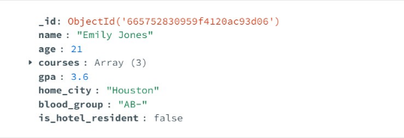
Example 1: Retrieve Name , Age, and GPA
db.condidates.find({},{name:1,age:1,gpa:1});
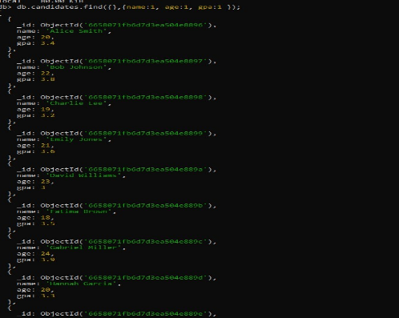
In this query we want to retrieve from, the matching documents name:1 :this include the name field in the result,age:1,gpa:1 :this include the age and gpa in the result.

Variation :exclude fields

db.candidates.find({},{_id:0,courses:0});

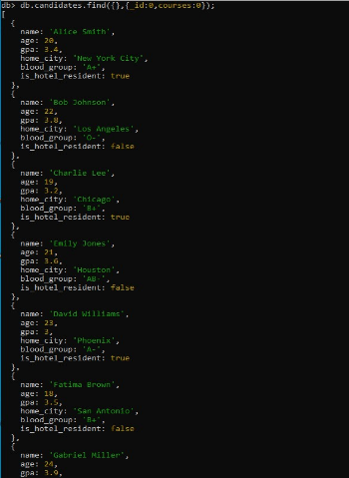
courses:0: This also sets the value of the courses field to 0, intending to exclude it from the results.

2.Projection operator($elemMatch):

The $elemMatch projection operator in MongoDB is used to filter elements within an array field when you're retrieving documents from a collection. It allows you to specify a condition that must be met by an element in the array for it to be included in the projected results.
Example 2: Find Candidates Enrolled in “Computer Science” with Specific Projection.
db. candidates. find({ courses:{ $elemMatch: {$eq:” Computer Science”}{name: 1, ”courses.$”:1});
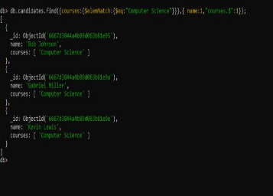

The query you have aims to find documents in the candidates collection where a candidate has "Computer Science" listed in their courses array. $elemMatch: This operator is used to filter documents based on specific criteria within an array field.$eq comparison operator to check if any element in the courses array has the exact value "Computer Science".

$elemMatch:

db. players. find({},(ganes:{$elemMatch:{score:{$gt:5}}},joined:1,lastlogin:1})
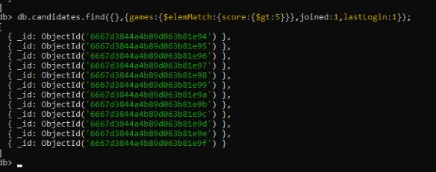
the aims to find players from the players collection who meet specific criteria. score:{$gt:5}: This query is used to find score property within a game object is greater than ($gt) 5. joined:1,lastlogin:1: This part uses projection to specify that you only want the joined and lastlogin fields to be returned for each matching player document.

- Projection operator($slice):

Example 3: Retrieve All Candidates with first two courses. db. candidates. find({},{ name:1,courses:{$slice:2}});

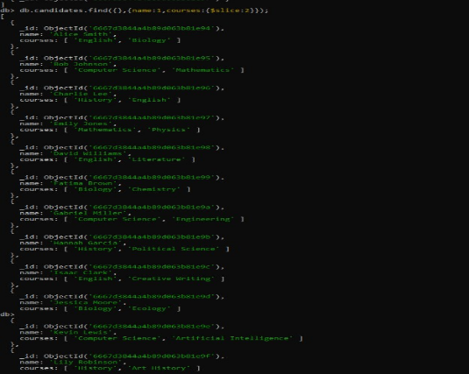

name:1: This includes the name field in the returned documents.
courses:{$slice:2}: This uses the $slice operator to limit the courses array to only the first two elements. If a candidate has fewer than two courses, the array will be empty.

$Slice:

The $slice operator in MongoDB is used to retrieve a specific portion of an array field within a document. It can be used in two contexts:

Projection: When used with the find or aggregation commands, it limits the number of elements returned from an array field in the query results.

Update: Though less common, $slice can also be used with update operations to modify an array field within a document.

